Drew Model Summer Calendar 3-5
July
Sunday | Monday | Tuesday | Wednesday | Thursday | Friday | Saturday
1 Attend the Smithsonian Folklife Festival on the National Mall (Free) | 2 President LBJ signed the Civil Rights Act. Read a biography about a Civil Rights leader. | 3 Write the multiplication and division fact families for the following sets of numbers: 3, 5, & 15 4, 6, & 24  2, 9, & 18 | 4 Happy Birthday USA! Read a book to or with a friend before you head out to see the fireworks. | 5 Go to the store with a parent. Record the time you arrive and the time you leave. How much time did you spend in the store? | 6 The 2018 World Cup is underway. Read about about an athlete or a sports story. | 7 10:30-4:00  Smithsonian TechQuest: Race to the Moon at the Steven F. Udvar-Hazy Center (Free)
8 10:00-5:00 Sound Scene XI: Mapping Memory Free event at the Hirshhorn (Free) | 9 July is hot but how else could you describe it? Write a poem about summer. | 10. Write an equation showing how 12 cookies could be shared between 2, 3, 4, and 6 children. | 11 Meet The Traveling Trolley at Drew Model  7:00 pm - 9:00 pm  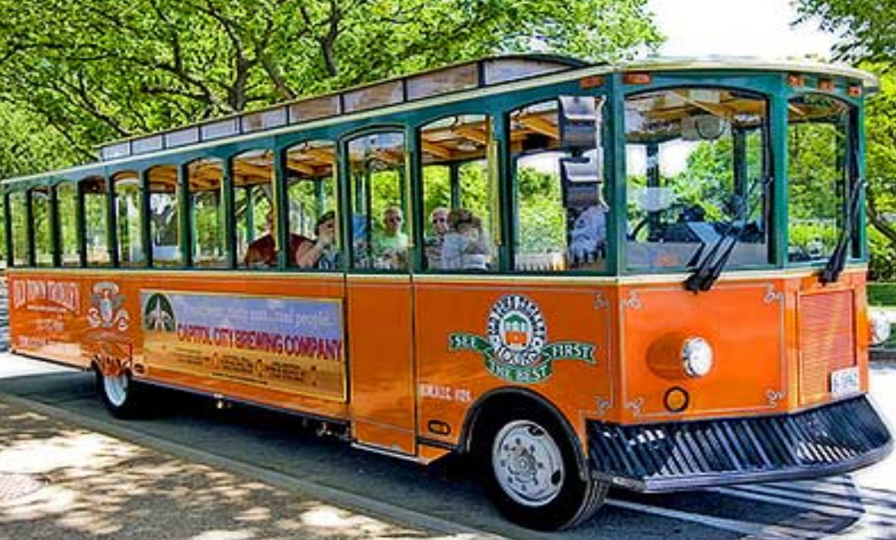 | 12 Count out fifty cards from a deck. See how many different ways you can divide them into equal groups. Write your division sentences on paper. | 13 See Coco at the Rosslyn Cinema Family Night starting at 5pm. Talk to your family about the recurring themes in this movie. | 14 10:00-3:00 STEAM Family Day at the Steven F. Udvar-Hazy Center (Free)
15 Take a picture of your favorite neighborhood spot edit it using the app Clips. Add some artistic effects. | 16 Yesterday was National Ice Cream Day, create a recipe for an ice cream sundae | 17 Write a story problem that can be solved using the number sentence  9 x 3 = ______.  And 45 X 6= _______ | 18 Meet The Traveling Trolley at Drew Model  7:00 pm - 9:00 pm  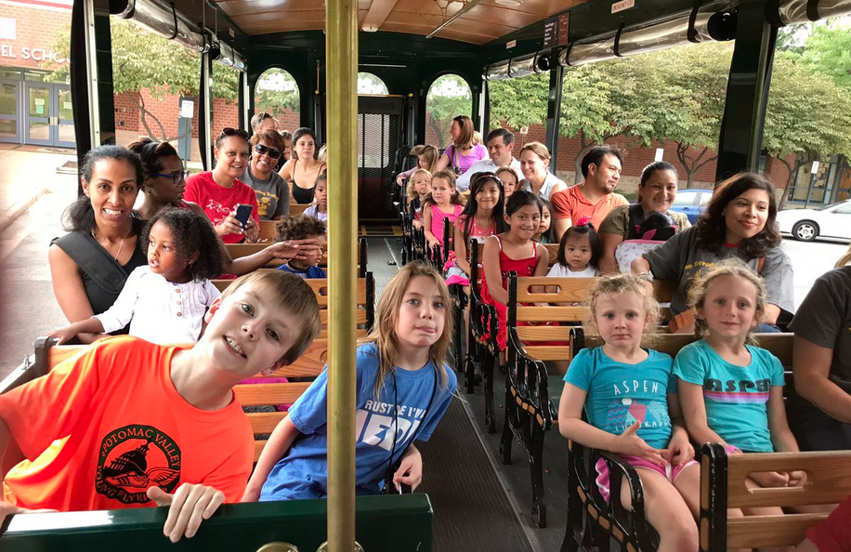 | 19 Select ten items from a grocery flyer and find the total cost of the items. Calculate how much change you would receive from a one hundred dollar bill. | 20 Read a book with a friend. Together, make an origami butterfly. | 21 Can you really fry an egg on a hot sidewalk? Make a hypothesis, grab an egg and crack it on the sidewalk. See what happens.
22 Find an empty box and turn it into a musical instrument. Other helpful materials: rubber band, beans, rice, paper towel roll. | 23 Stuffed Animal at Shirlington Library! Join the librarians for a special pajama storytime, then leave your stuffed friends in the care of our Librarians for the evening. Pick up your friends after 1pm on Tuesday, July 24. | 24 Find a chapter book you want to read. If you were to read this book in exactly one week, how many pages would you have to read each day, if you read the same number of pages each day? Start reading the book today and see if you can finish it within seven days. | 25 Meet The Traveling Trolley at Drew Model  7:00 pm - 9:00 pm | 26 Measure the length and width of your bedroom. Multiply to find the area. Be sure to label your answer with the correct unit of measurement. | 27 Tonight is a full moon, go outside and see for yourself! Read a book about the solar system. | 28 Visit the Planetarium at Rock Creek Park at 1:00pm for the Seasonal Night Sky Program (Free)
29 Watch airplanes takeoff and land at Gravelly Point | 30 Read a nonfiction book and learn something new! | 31 Flip a coin 25 times. Write a fraction to show how many times it came up heads and one to show how many times it came up tails.

August
Sunday | Monday | Tuesday | Wednesday | Thursday | Friday | Saturday
 |  |  | 1 Meet The Traveling Trolley at Drew Model  7:00 pm - 9:00 pm | 2 Linda is going to have new flooring put in her bedroom. If her bedroom is 8 feet by 10 feet, how many square feet of flooring will be needed? What is the area and perimeter of Linda’s bedroom? | 3 National Watermelon Day! Learn “How Much Water is in a Watermelon?” | 4 10:00-4:00 Become an inventor at the American History Museum’s Spark!Lab
5 Grab your art supplies and paper and make a card for your principal, Ms. Graves or Ms. Genove. | 6 Visualize a part of the book you are reading. Then, make your own illustration of that scene. | 7 On a sheet of paper list your multiplication tables (through 12)for 3's, 4’s, and 5’s. | 8 Today is International Cat Day. Go to the library and check out a book about cats. | 9 Count by 10’s until you get 110! How many times did you count? | 10 Today is National S’mores Day. Write a recipe for the best S’more. | 11 View the partial solar eclipse
12 Build a boat out of tin foil, tape and popsicle sticks. Test it in a sink or bathtub. Does it float? | 13 It’s International Left Handers Day! Read about a ship Left-Handed Fate in the fantasy novel by the same name. | 14 Name some capital letters that when printed have at least one pair of parallel lines. | 15 Read a nonfiction book and learn something new! | 16 Tyler sent a package with one 60 cent stamp, four 32 cent stamps, three 25 cent stamps, and four one cent stamps. What was the total postage on the package? | 17 See The Lion King at the Rosslyn Cinema Family Night starting at 5pm. How is the movie the same and different from our school production of The Lion King? | 18 10:30-12:00 Island Safari guided tour of Roosevelt Island (Free)
19 (11:30, 12:30 & 1:30) Visit the Natural History Museum to see a live tarantula feeding! (Free) | 20 Today is National Radio Day. Listen to music while you are reading a chapter book. | 21 Practice your 7 8 and 9 tables on a piece of paper | 22 It’s National Tooth Fairy Month. Write your own story about the tooth fairy. | 23 Tyler ate 6/8 of a pizza. How many slices are left? Write your answer as a fraction. | 24 Write an antonym (opposite) for each word listed below.  above  defend  sunny  heavy  front  shallow | 25 Create an iMovie trailer about what you did over your summer break.
26 Make observations of the the full moon in the night sky. What do you notice? | 27 Read a Graphic Novel. After you finish write and illustrate a sequel. | 28 Survey 10 people and ask them what their favorite animal is. Create a bar graph to show your results. | 29 Visit another country by reading a book! | 30 Buy a small bag of M&M’s. Pour them into a jar. Estimate how many M&M’s are in the jar. Count the candy to see how close you are. | 31 Write a letter to your teacher from last year. Tell them about your summer and your favorite memories from class.

