DREW Model Summer Activity Calendar K-2
July
Sunday | Monday | Tuesday | Wednesday | Thursday | Friday | Saturday
1 Attend the Smithsonian Folklife Festival on the National Mall (Free) | 2 Read a book to a stuffed animal. | 3 Take turns with a partner counting by 5’s until you get to 100. | 4 Happy Birthday USA! Read a book to or with a friend before you head out to see the fireworks. | 5 Make a chart looking for all the squares and rectangles in your home | 6 Read the signs you see while riding in the car. | 7 11:00 am “Flights of Fancy” Story Time at the AIr and Space Museum (Free)
8 10:00-5:00 Sound Scene XI: Mapping Memory Free event at the Hirshhorn (Free) | 9 Ask your child what is special about the letters A, E, I, O, and U? | 10 Grab a handful of blocks or fruit loop cereal (or any fairly large cereal). Estimate how many you have in your hand. Count the objects and write the number. | 11 Meet The Traveling Trolley at Drew Model  7:00 pm - 9:00 pm 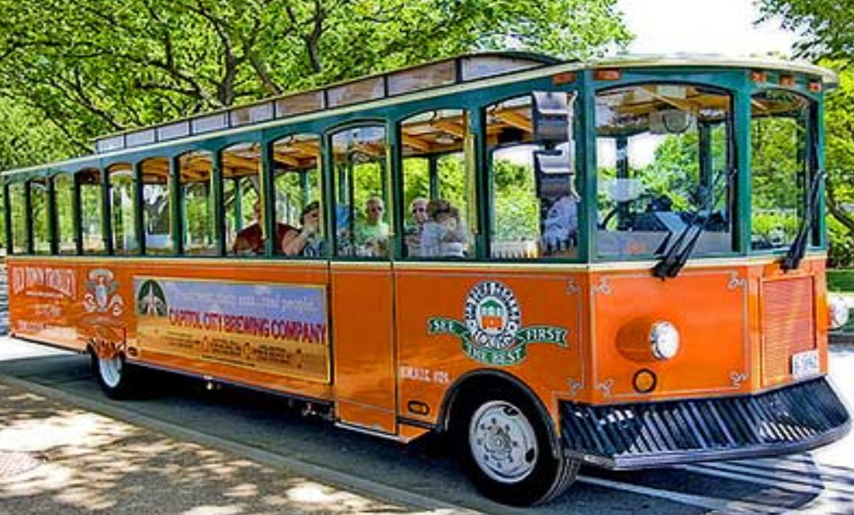 | 12 Today’s date is 12. Write a number sentence that equals 12. | 13 See Coco at the Rosslyn Cinema Family Night starting at 5pm. Talk to your family about what you liked about this movie. | 14 10:00-3:00 STEAM Family Day at the Steven F. Udvar-Hazy Center (Free)
15 Visit the National Gallery of Art and participate in the Art Investigator’s Program (Free) | 16 Yesterday was National Ice Cream Day, read a book about Ice Cream. | 17 Sort some of your toys into categories. Explain the categories to a friend or family member. | 18 Meet The Traveling Trolley at Drew Model  7:00 pm - 9:00 pm  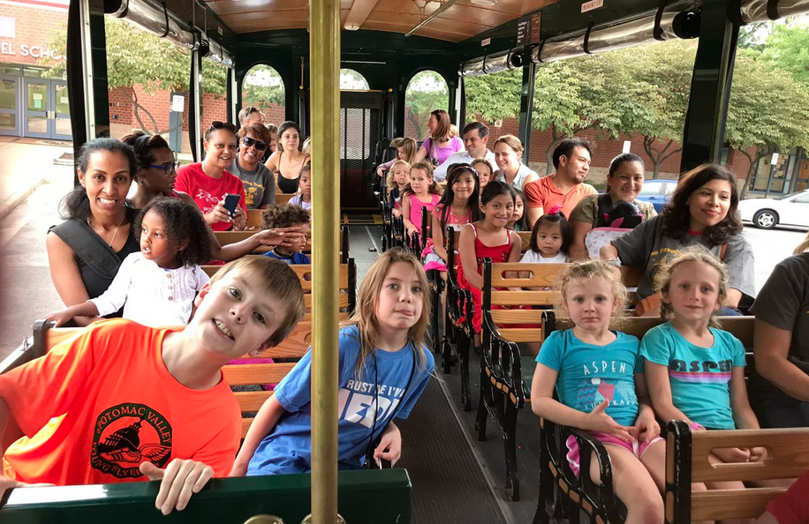 | 19 How many jumping jacks can you do in one minute? Is it more or less than 20? How do you know? | 20 Read with a friend or sibling. | 21 Visit the Children’s Garden at the US Botanic Garden in DC (Free)
22 Find an empty box and turn it into a musical instrument. Other helpful materials: rubber band, beans, rice, paper towel roll. | 23 Stuffed Animal at Shirlington Library! Join the librarians for a special pajama storytime, then leave your stuffed friends in the care of our Librarians for the evening. Pick up your friends after 1pm on Tuesday, July 24, along with photos of their overnight Library adventures. | 24 Use a ruler to measure the length of something in inches. Would this measurement change if you measured in centimeters? Explain. | 25 Meet The Traveling Trolley at Drew Model  7:00 pm - 9:00 pm | 26 Antonio made a cake for his sister’s birthday. He cut the cake into 4 equal pieces. He gave one piece to his sister. Draw a picture of how he may have cut the cake. | 27 Tonight is a full moon, go outside and see for yourself! Read a book about the solar system. | 28 Visit the Planetarium at Rock Creek Park at 1:00pm for the Seasonal Night Sky Program (Free)
29 Watch airplanes takeoff and land at Gravelly Point. | 30 Read a book and illustrate your favorite part. | 31 How many ways can you make 25 cents using pennies, nickels, dimes, and quarters?

August
Sunday | Monday | Tuesday | Wednesday | Thursday | Friday | Saturday
 |  |  | 1 Meet The Traveling Trolley at Drew Model  7:00 pm - 9:00 pm | 2 Go to the park or take a walk with a family member. Draw the solid shapes you see. Label your picture | 3 National Watermelon Day! Read a book about watermelon! | 4 9:00-2:00  Old Town Alexandria  Friendship Firehouse Festival (Free)
5 Go outside and collect leaves, sticks, flowers and other natural things from the ground. Create a collage or pattern. | 6 Practice your letter writing skills by writing a letter to a friend or family member. | 7 Mina had 15 flowers. She gave some to her mother. Now Mina has 6 flowers. How many flowers did Mina give to her mother? Write a number sentence and solve. | 8 Grab your flashlight and find a dark place to read your book with your flashlight. | 9 Tell the time that you go to bed to the closest hour or half hour. Draw a picture of the clock’s hands for that hour. | 10 Today is National S’mores Day. Find a Recipe for S’mores and make them. | 11 View the partial solar eclipse.
12 Grab your art supplies and paper and make a card for your principal, Ms. Graves or Ms. Genove. | 13 It’s International Left Handers Day! Try to write your name with your left-hand. | 14 I am thinking of a shape. It has straight sides. It has no square corners. What shapes could it be? Draw all the possibilities and describe the shapes to a family member. | 15 Read a nonfiction book and learn something new! | 16 Have a parent/guardian time how long it takes you to solve the following problems.  3+4= 3+3=  8-3= 7-6=  10-6= 9-7=  5+3= 7+3=  8-1= 9-2= | 17 See The Lion King at the Rosslyn Cinema Family Night starting at 5pm. Talk to your family about what you liked about this movie. | 18 10:30-12:00 Island Safari guided tour of Roosevelt Island (Free)
19 (11:30, 12:30 & 1:30) Visit the Natural History Museum to see a live tarantula feeding! (Free) | 20 Read a book about your favorite animal. | 21 Start at the number 34 and count up to 60 | 22 It’s National Tooth Fairy Month. Read a book about the tooth fairy or dental health. | 23 Count backwards from 26 to 0 | 24 Put these words in alphabetical order: and, it, the, went, she, he | 25 Enrichment Day at the National Zoo (Free)
26 Make observations of the the full moon in the night sky. What do you notice? | 27 Look at the word Mississippi. How many vowels are in this word? How many consonants? | 28 Gather five different boxes of food such as rice or cereal. Measure the height of each box in inches. Which box is the tallest? Which box is the shortest? | 29 Visit another country by reading a book. | 30 Using a group of different coins, sort the coins into groups of the same kind. How much is in each group? | 31 Go on a family picnic. Don’t forget to pack books and read after you eat.

