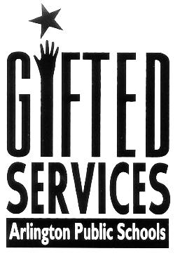

# Date: October 29, 2018

# Time: 6:00-7:00 PM

# Location: Drew Library

**Topics Covered:**

* **How Gifted Services are administered here at Drew Model School**
* **The role of our Resource Teachers for the Gifted**
* **APS Gifted Identification Process**
* **The opportunity to ask questions**

**For more information, please contact Kristina Farrell, Resource Teacher for the Gifted Kristina. Farrell@apsva.us**

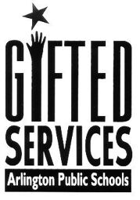

Please Join Us

Gifted services Information Night