School Talk

December 14, 2018

Inside this edition:

- Program News
- Food & Gift Card Drives End Next Week
- PTA News
- Upcoming Dates
- Links
- A Montessori Moment

PROGRAM NEWS
-5th Grade to Visit Gunston The Montessori 5th graders will be going to visit and tour Gunston Middle School on Wednesday, December 19th at 10AM. This is a visit to allow the children to see the facilities, talk with administration about the school and meet and speak to students. Please send back the permission slips if you have not already. We have already secured enough parent chaperones for this trip. We know that our 5th grade parents are as excited to learn about Gunston but we ask that you do not show up for this field trip as Gunston wants to limit parents so that the event is student-centered and they can ask their questions without parents cutting into the time to ask theirs. For parents who do want to learn more about Gunston, there is an upcoming information session just for you! January 24th at 7PM. There will be one in Spanish on January 15th also at 7PM.
-The deadline for Middle School transfers is January 18th. This includes applications for the H-B Woodlawn lottery. Go to https://www.apsva.us/school-options/middle-school-choices/request-a-transfer/ for more information and to the link to the online application portal.

FOOD & GIFT CARD DRIVES END NEXT WEEK
The Drew Safety Patrols are holding a canned food drive from now through December 20th. The food will be disbursed to families in need in our community. Drop off your canned goods and non-perishable items to the collection area in the lobby in front of the main office. This is a whole school effort. Any questions? E-mail Tenita Chapman or Leroy Dewitt or call 703-228-8135.
Gift Card Drive through December 17th The Drew & Montessori counselors are collecting grocery store gift cards to help sustain our families at risk of food insecurity over the 2-week holiday break. If you are so inclined, drop off your gift card(s) to either Ms. Reeser or Ms. Grogan in the main office by December 17th. Visa/AmEx gift cards are fine. Please no cash/check donations. Please no restaurant gift cards. Gift cards from stores with a grocery store within, like Target or Walmart, are also welcome.

PTA NEWS
-TOMORROW IS THE MAKERS FAIR! Our crafters are excited to show you what they can do! We will have all sorts of handmade goods, from chocolate spoons to magic wands, handcrafted pillows to baked goods, and more! We are also happy to announce that Silver Knights Enrichment will be offering for FREE two LEGO Robotics classes (space is limited). Saturday, December 15th in the auditorium of the Central Library, 11AM to 1PM. Open to everyone! Spread the word! Something to keep in mind: Most items will be priced under $5 so please try and bring small bills if you can. Thank you!
-CCPTA Reflections competition winners have been announced! Congratulations to all who received recognition.
- Dance: Natalia Thornton (Primary Division) received the School Award of Excellence.
- Literature: Noah Golden (Intermediate Division) received an Award of Merit.
- Music: Madison McBeth (Primary Division) received Outstanding Interpretation of the Theme and will move forward to the NoVa District PTA Reflections competition.
- Photography: Delaney Stein (Intermediate Division) received an Award of Merit.
- Visual Arts: Nandini Kirwin (Primary Division) received Outstanding Interpretation of the Theme and will move forward to the regional Reflections competition; Alisha Oberoi (Intermediate Division) received an Award of Merit.
-When you shop for the holidays, change your Amazon Smile donation to us! Please sign up for Amazon Smile and choose Arlington County Montessori PTA as your charity! To make it easier, direct your browser to https://tinyurl.com/MontessoriSmile. Every time you shop, we earn money, so please remember to sign up and ask your friends and family to sign up as well.

UPCOMING DATES
- Thursday, December 20: Primary Montessori Gingerbread House-making Event
- Monday, December 24 – January 4th: Winter Break

LINKS
- Arlington Montessori Program on APS: https://drew.apsva.us/the-montessori-program/
- Principal Genove on Twitter: https://twitter.com/CSGenove
- Engage with APS https://www.apsva.us/engage/
- Lunch Menus: https://apsva.nutrislice.com/menus-eula-splash
- Arlington Montessori PTA: https://acmpta.com/.

A MONTESSORI MOMENT
This week, some background about the creator of the Montessori method, Dr. Maria Montessori.

Maria Montessori
Excerpt from a post by Brickton Montessori School

"No one can be free unless he is independent."
-- Maria Montessori
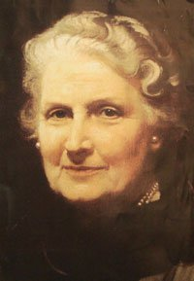

Maria Montessori: Life and Work
Maria was born in Rome, Italy in 1870 to an upper middle class family. Her parents wanted her to be a housewife, as were most women of her generation, but Maria had other ideas. In 1896, she became the first female doctor in all of Italy. It was very hard for her to become a doctor because all of the other doctors were men. The men made fun of her and threatened her. All she could do was block them out. Because of this, Maria never married.
After that she started working with disabled children. Maria devised a new method of education because she thought the method in place at the time was not serving the needs of the children. She observed that children have developmental periods in which they are primed to learn different things.
Her approach to teaching disabled children was very different than anyone else’s at the time. Instead of the traditional methods that included reading and reciting, she taught the children by using concrete materials, which worked very well. Learning was not memorizing but sensing and experiencing things. The disabled children scored higher on the same test that the regular children took; then she got an idea: “Why can’t normal children benefit from the same method?” So she opened a Casa dei Bambini or Children’s House in the slums of Rome. She moved around Europe for a while until she settled in Italy again after World War II and the fascist government was no longer. Montessori had a big impact on education; because her methods were different, she opened up a new light on the subject.
She died in 1952, but her legacy, with over 150 schools in the US and even more worldwide, lives on.

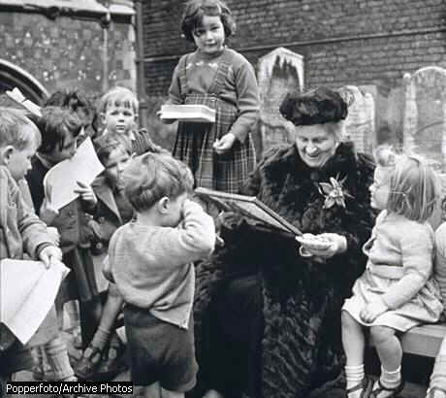

Children’s House is a Montessori program in which children three to six years old are in one classroom. Montessori developed a system for teaching children differently from the usual way where children sit at fixed desks, listening to lectures. The Montessori method is based on the premise that the child wants to learn, and independence and order are key.
Maria Montessori came up with this method from observing the development of children. She found out children have sensitive periods. From birth through six years is a very crucial time for young children when they must learn independence and order to understand the huge world that is before them.

