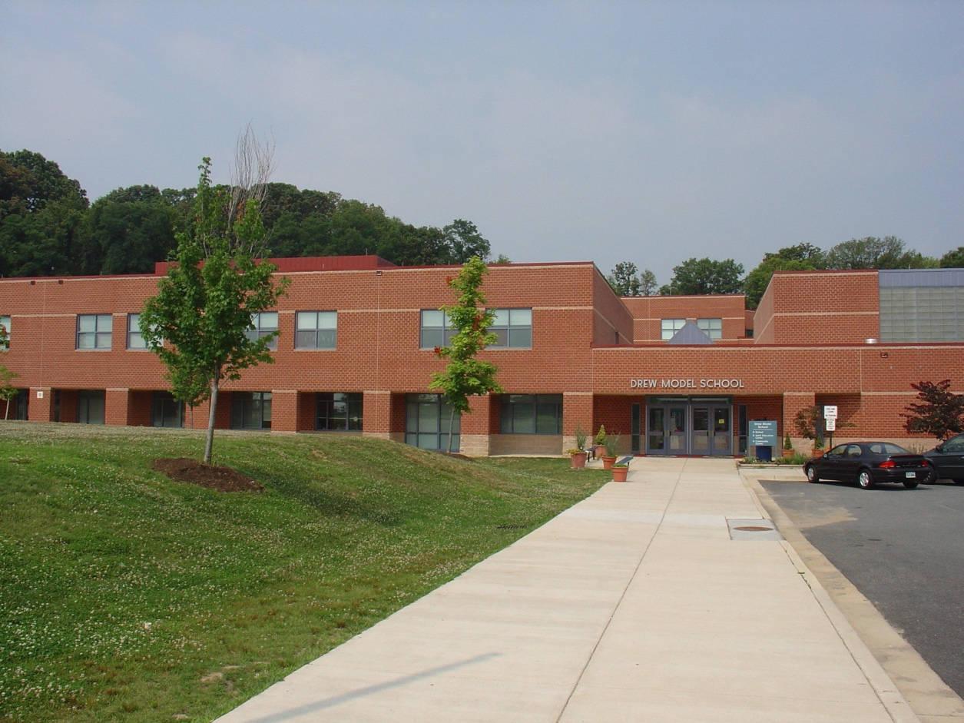  Drew Model Elementary School  “Building Our School Community”  Parent Engagement Meeting  Current and new parents and families are invited to attend a series of Community Engagement meetings focused on building our school community. The meetings will be designed to provide families and parents with information about our school and create opportunities for parents and families to engage with school staff.  TOPIC OF DISCUSSION: Student Support Services | WHEN:  March 26th @ 7:00pm  WHERE:  Drew Model Elementary School  3500 23rd Street  Arlington, VA. 22206  NEXT MEETINGS  April 24th  May 29th

