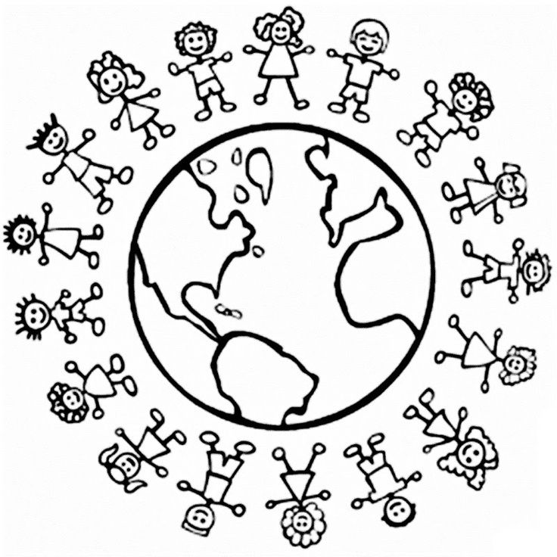
Multicultural Night 2019

Tuesday, April 30th , 6:00 p.m. - 8:00 p.m.

Join us to celebrate the rich diversity within our school community!

Interactive Learning Stations
Students will be given passports to travel around the world and learn about different cultures through interactive learning activities.
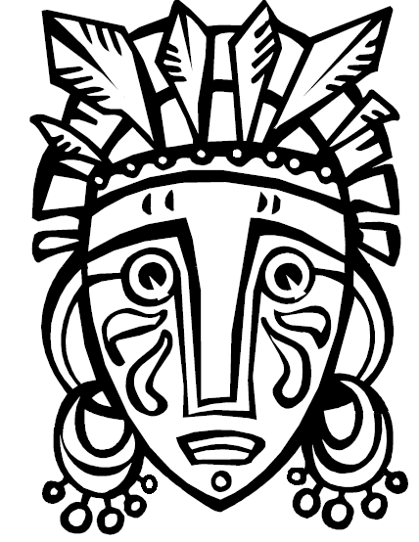

Multicultural Tastes
Families are invited to bring a dish from their culture to share with the entire school community! See next page for more details and to sign up to bring a dish. During Multicultural Night, families will have an opportunity to sample a taste of foods from around the world. Each person will also get one slice of delicious pizza. The food is free!
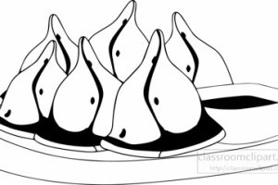

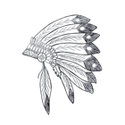
We encourage families to come dressed in traditional clothing!

Student Cultural Me-seum Exhibits
Come learn about the many cultures that make up our school community by viewing student Me-seums! Drew Model and Montessori students will be proudly representing and teaching the community about their culture through Me-seums! It’s easy. Students grab a shoebox, a few photographs, and art supplies to create a personalized 3-dimensional presentation about their culture. All students will be given directions about to complete their Me-seum at home with their family.

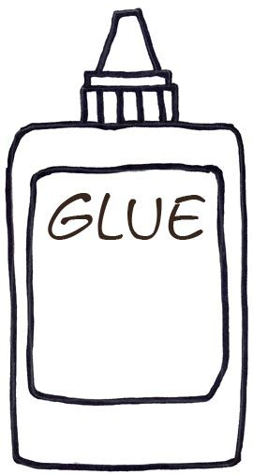

Get involved! Share your culture! See next page for more information.
Cultural Performance
Do you have a cultural song or dance that you would like share with the community on stage? We welcome you! Share your cultural dance or song with the community. Please contact Chandra Perkins at chandra.perkins@apsva.us or 703-228-5825 ext. 199209.

Community Potluck
People love learning about culture through authentic food. Share an authentic dish from your culture with the school community. The dish must be large enough to serve small samples to at least 70 people. Use this link to sign up https://www.surveymonkey.com/r/YDBP3WX
or use the QR code.

Community Cultural Presentation
Would you like to teach the school community all about your culture? We invite community members to share presentations that teach all about culture. You may present a display, activity, craft, or game. Space is limited. There will be a selection process. Use this link to sign up https://www.surveymonkey.com/r/2V2VS65
or use the QR code.
