School Talk

March 1, 2019

Inside this edition:

- Why Parent-Teacher Conferences are SO Important
- Read the Superintendent’s Budget for SY2020
- Program News
- Teacher’s Corner
- PTA News
- Upcoming Dates
- Links
- A Montessori Moment

WHY PARENT-TEACHER CONFERENCES ARE SO IMPORTANT
Kids and teens do better in school when parents get involved. Attending parent–teacher conferences is one way to be involved and help your child succeed.
A parent–teacher conference is a great opportunity to:
- discuss your child's progress;
- share your child's strengths and needs; and
- work with the teacher to help your child do well in school.
Spring Parent-Teacher conferences are being arranged now and will take place next week. Thursday, March 7 is an early release day and conferences will be held in the afternoon. Friday, March 8 is no school for students and conferences will be held throughout the day. It is never too late to sign up for a conference. If the times available do not work for you, talk to your child’s teacher about possibly scheduling at an alternate time. Translation is available – just let your teacher know.

READ THE SUPERINTENDENT’S BUDGET SY2020
Last night, Superintendent Patrick Murphy and his Budget & Finance team presented his proposed budget for SY2020. The link to the budget is: https://www.apsva.us/wp-content/uploads/2019/02/FY-2020-Superintendents-Proposed-Budget.pdf
If the budget is fully funded, meaning the $8.9M gap is closed, then the budget as presented will move forward with the Tier 1 plan. Should that gap not be filled, we will move to Tier 2, which means specific reduction (listed in the budget). Should the County Manager’s proposal for a 1.5 cent tax increase be rejected, then APS will need to go to Tier 3 reductions.
Budget Calendar:
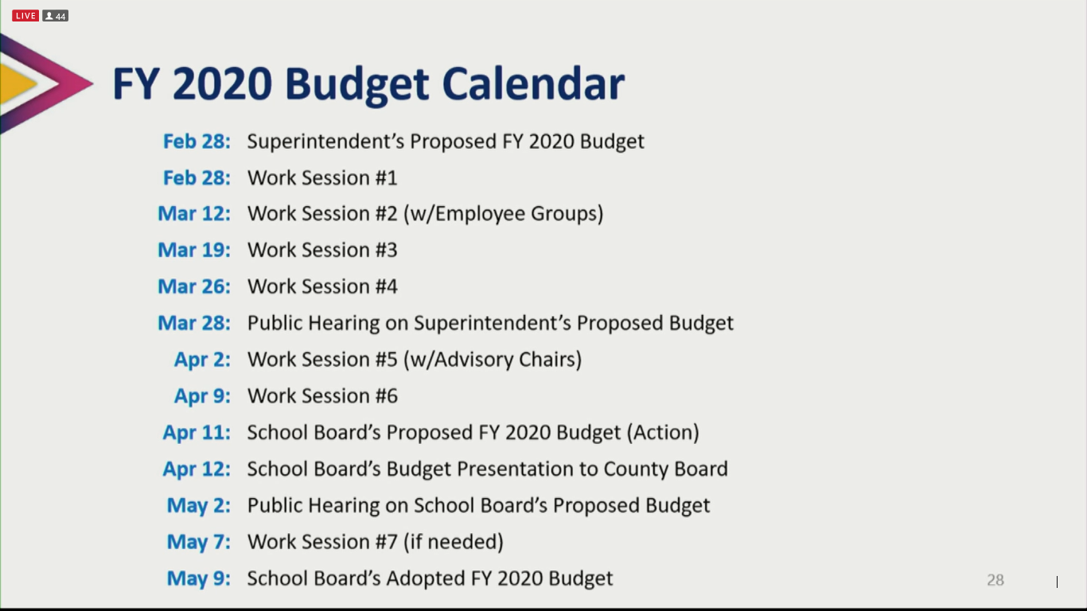

PROGRAM NEWS
-The Extended Day registration process has changed! Extended Day and Check-in (Middle School) has now become a double blind lottery process. Families may submit registration information anytime between April 1 – May 15, for participation in the 2019 Summer Program and the 2019-20 School Year. All registrations received between April 1–May 15 will be considered equally. https://www.apsva.us/extended-day/registration/
-Summer School Registration Begins March 7. APS provides a variety of summer programs for students in Pre-K through Grade 12. Most classes begin on July 8. Registration for Summer School begins on Thursday, March 7. To see a list of registration dates and other information as well as the Summer School Catalog: https://www.apsva.us/post/summer-school-registration-begins-march-7/
-Celebrate National School Breakfast Week with Free Breakfast! National School Breakfast Week is March 4-8. The National School Breakfast Week campaign theme, "Start Your Engines," reminds the community that school breakfast provides a healthy and energizing start to the day for students. Arlington Public Schools hopes to give students the opportunity to start their engines with school breakfast by hosting a week of free meals.
-Order Your 2018-2019 Yearbook! Orders are currently being taken for the 2018-2019 Drew Model School Yearbook. This yearbook includes BOTH Programs, so Montessori students should order this one if they would like a memoire of the year. Order forms went home in this past Thursday’s backpack mail. Send back to school with a check or money order (NO cash please!) made out to “Drew Model School”. Or you may order online at www.ybpay.lifetouch.com today!

TEACHER’S CORNER
Want to see which of your child’s favorite teachers can sing like a professional? Or which PTA moms and dads can shake a tail feather on the dancefloor? March 6 at 6:30PM is the night you can discover all this and more! The first ever Parent-Staff Talent show is next week! This is going to be loads of fun…and rumor has it your PTA president will be dancing in it. Come out to see all this talent hidden within our walls but also to support a very good cause. This event is a fundraiser to help our After School Choir, comprised of both Montessori & Model students, fund their annual trip to this year's Chorale Music Festival in Williamsburg, VA, where our choir has prevailed as multi-year 1st place winners! Your attendance will help with this! Tickets are $1 for students, $3 for adults. Sold at the door. Concessions will be sold as well, everything costing $1. All are welcome to attend!

PTA NEWS
It was announced last night during the budget presentation that our program will be losing the 2 temporary assistants we received for our transition period, leaving us with a total of 14 assistants for next year. That is 7 for Primary and 7 to be shared between the Elementary classes (13 as of now). Please follow this link to the letter AMAC has sent to the School Board and APS Senior Staff. It expresses our concerns and offers some concessions that we may be able to make as a program to regain some, if not all, of our assistants: https://bit.ly/2VpcfqO
Please keep in mind, that as AMAC and the administration are in discussions trying to figure out solutions, this is not the time for angry e-mails, office visits or School Board speakers. The county has made it clear that there is no money to be found for anything more than is written in this budget as this year the overall budget is unlike one we’ve ever seen before in Arlington. Concessions are the only way we will be able to get what we need. If you want to be helpful, what you can do is write to the School Board and APS Senior Staff and show your support for the AMAC letter and the concessions we have suggested – or even come up with some of your own.
Also, this is a reminder that while the PTA can promote advocacy, we are prohibited by National PTA bylaws to engage in political business, so while we can do some things, we will have to rely on advocacy groups like AMAC to do the heavy hitting. This is one reason why we've been so adamant about our membership joining the AMAC listserv. Another is we'd like to keep our focus steady on building up our community and supporting our program's staff no matter what the outcome is.
Thank you for your patience and understanding. - ACMPTA

UPCOMING DATES
- March 3-9: National Foreign Language Week
- March 4-8: Free Breakfast for all APS students
- March 6: Staff/Parent Talent Show, 6:30PM
- March 7: Early Release – Parent/Teacher Conferences. Students dismissed at 1:26PM
- March 8: No School for Students – Parent/Teacher Conferences all day.

LINKS
- Arlington Montessori Program on APS: https://drew.apsva.us/the-montessori-program/
- Principal Genove on Twitter: https://twitter.com/CSGenove
- Engage with APS https://www.apsva.us/engage/
- Lunch Menus: https://apsva.nutrislice.com/menus-eula-splash
- Arlington Montessori PTA: https://acmpta.com/.

A MONTESSORI MOMENT

Montessori Vocabulary 101

Development of the Will: The ability to will, or choose to do something with conscious intent, develops gradually during the first phase of life and is strengthened through practice. The Montessori environment offers many opportunities for the child to choose. Willpower, or self-control, results from the many little choices of daily life in a Montessori school.

Work In Montessori
By Ana Amiguet for MariaMontessori.org and featuring students from Ms. Kalkus’ Primary classroom

For most of us, the word “work” carries the heavy connotation of all the things we are supposed to do—but really want to avoid. It brings visions of stress and ulcers, of late nights and stale coffee. But if you are one of the lucky few who truly loves what you do, then “work” means something completely different. “Work” then means doing something that brings satisfaction and gratification, it means gladly giving of yourself to complete a task, and it means knowing that you will be rewarded with something more than material gain—joy in the process itself. It is this positive experience—of undertaking an activity that fulfills your mind, body and heart—that a child experiences in a Montessori environment. It is this that we mean by “work.”

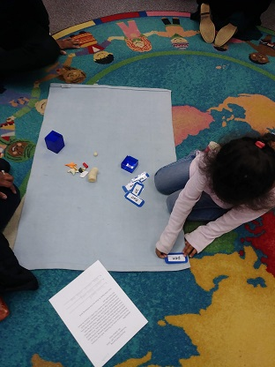

But what is the difference between the kind of work which is an obligation and a chore, and the work that fulfills the spirit and the mind? First, it is important to realize that work in a Montessori environment is not forced on a child, but is instead freely chosen. A Montessori environment offers the child the liberty of choosing their own activities, and they have consistently, and independently, chosen work that serves a developmental purpose. Through this work, children show an ability to concentrate for long periods of time, a propensity for repeating an activity until a certain skill is mastered, and the urge to make the maximum effort on any task. Additionally, children demonstrate a great sense of joy while performing their work, and indicate that they want to learn how to be a help to their family or community, and contribute with the skills and the knowledge they have acquired.

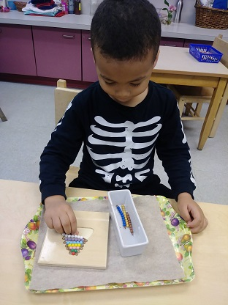
In order for work to be an enjoyable experience, however, it needs to engage the whole personality, as it is then that the child can experience, “… the kind of pleasure and satisfaction that results only when basic needs are gratified,” (Mario Montessori, Jr., Clio, 1992). Differently from adults, a child performs a task not for the end result, but for the process itself. For example, in working with the Dressing Frames, and in learning how to tie bows, the child concentrates on a task that is helping him refine his fine motor skills, giving him independence from having to ask an adult to tie his shoes, and challenging both his fingers and his mind to complete the task at hand. In this simple activity, the child is able to integrate his personality, as the work addresses the development of his physical, emotional, and intellectual self.
Also, work in a Montessori environment always has multiple purposes, as one activity will indirectly prepare the child, and set him up for success, in other areas (of both the classroom and of life!). For instance, the child does not learn to wash a table merely so that it will be clean, but because learning to follow a complicated series of steps will help organize his mind, leading to the logical and ordered thinking required in the more advanced mathematics materials. Later, having a mind that can bring order out of chaos will help the future adult become an engineer, manage a company, or do his taxes! And it is imperative that the child is exposed to this kind of work before he is 6 years old, since this is when he is still forming his personality, and his mind. In this way, the child has the chance to be an organized person, as opposed to someone who realizes they need to be organized, and forces themselves to learn.
All in all, Montessori strives to erase the negative connotations imposed on the word “work” and replace it with what it should mean: work (verb) to carry out a purposeful activity that fulfills an inner purpose, and helps the person integrate his mind, body and soul.
