School Talk

March 15, 2019

Inside this edition:

- 16 Teachers Going to the AMS Conference! Yay!
- 5th Grade Overnight to 4-H
- Walk for Water
- Program News
- Teacher’s Corner
- Reminders
- PTA News
- Upcoming Dates
- Links
- A Montessori Moment

16 TEACHERS GOING TO THE AMS CONFERENCE! YAY!
The PTA set a goal to help send as many of our Montessori teachers as they could to the American Montessori Society (AMS) Annual Conference. With your generous donations and some available school funds, we are happy to say that 16 teachers and Ms. Nashid will be attending! The conference begins next week on Thursday, March 20th through Sunday, March 24th.
The teachers will have substitutes so this would be a wonderful time to remind your children to use their Montessori Grace and Courtesy practices while their teachers are out - that we want everyone to feel welcome to the classroom, even if it is only for a short moment of time. If any parents have some free time to help out in class next week, please let your teacher know. Some room parents may have already sent out a request. Thank you in advance.

5th GRADE OVERNIGHT TO 4-H
This is a reminder that the annual 5th grade overnight field trip to the 4-H Center in Front Royal Virginia is next month, April 11th and 12th. Fortunately, due to some leftover funds, we were able to lower the price of the trip to $89 per student/chaperone (from $114 dollars). Permission slips will be coming home soon. Please return them, along with payment, back to school as soon as possible so we can save their place. If you’d like to be a chaperone, e-mail Kia Haynes at khaynes74@gmail.com. We have limited seats on the bus for chaperones, so please let her know if you would be willing to drive yourself to 4-H and back in your e-mail.
Also, if you are willing and able to, let us know if you’d be willing to sponsor the cost for a child to go. We do have some children for whom the trip cost may be a burden. E-mail Ms. Lopatkiewicz at Eileen.lopatkiewicz@apsva.us if you can do this.
WALK FOR WATER
Thanks to all the families and staff for supporting Amman Imman-Water is Life project at school. Many jars of collected coins were turned in and the children seem to be very proud of their contributions.
As a culminating event, some classrooms will participate in a small Walk for Water at 2PM on March 20th on the field at Drew. An African drummer will accompany them to add culture, rhythm and fun. The idea is to walk in solidarity with the children of the Azawak, children who walk up to 30 miles a day to bring water to their families. Everyone will walk across the field 20-30 times, a small portion of what the Azawak children walk, carrying a jug of water to drive home the effort it takes for them to have fresh water. The activity will end with a big circle and singing of “Light a Candle for Peace”. Parents can join. Please ask your teacher if their class is participating. In the event of rain, we will have a short drumming performance in the community center.

PROGRAM NEWS
-Join the Multicultural Night Committee It’s time to plan our annual Multicultural Night, one of our school’s most favorite events. This year, parents and staff are being invited to take part in the planning. If you would like to join, please attend our first meeting. Wednesday, March 19th at 4PM in the library. The meeting shouldn’t last more than an hour. Any questions? E-mail the lead on this project, Ms. Chandra Perkins at chandra.perkins@apsva.us. Multicultural Night will be celebrated by Model and Montessori together.
-Preschool Caregiver Resource Fair (for children up to age 5). Parents and caregivers of infants and preschoolers: Please join APS on Saturday, March 23 at the FREE 11th annual Child Development Resource Fair at Kenmore Middle School. This event will provide information and resources for Arlington families and caregivers with infants and preschoolers up to age five. The featured topic is screentime, its effects and practical tips related to reducing screentime. https://www.apsva.us/wp-content/uploads/2019/02/2019-Resource-Fair-Flyer-English-Spanish.pdf
-APS Bus Transportation Service Review As the school system has grown and changed, APS transportation challenges have also increased. This Spring, APS is conducting a review of their service, policies and procedures to help create a long-term vision for the bus transportation system and find new solutions to safely deliver students to school on time and ready to learn. They are seeking input from all APS families and community members – bus riders, walkers and those who use other transportation options. Several community workshops are planned from March 25-April 6, and a community questionnaire will go out through School Talk next week to gather input on bus transportation and help inform changes for the 2019-20 school year and beyond. Visit Engage with APS! to learn more and view the event schedule.
-Teachers! Apply for a grant from the CCPTA! The CCPTA deadline for the Spring CPCI grants is March 25th. Read more about it here: https://ccpta.apsva.us/cpci/

TEACHER’S CORNER
From Music teacher, Ms. Shakespeare:
Voce, NoVa’s premier chamber music ensemble, is looking for student singers aged 8-18 to perform in a production of Benjamin Britten’s Noye’s Fludde (Noah’s Flood). Noye’s Fludde is a one-act opera that features a large (40+) children’s choir to act as the animals boarding Noah’s Ark. The performance expertly blends professional singers, a chamber orchestra, and a youth choir and orchestra. It is a wonderful, unique experience that can’t be found anywhere else!
Students who participate will sing alongside professional opera singers and Voce, which is a Vienna-based choir comprised of music professionals and experienced singers from the surrounding communities. [https://www.voce.org/] They will get to design their own animal masks and ultimately perform on Sunday, May 19!
Here is a link for the google doc where you can find further information and registration: Voce Noye's Fludde Student Chorus Flyer
Email any questions to charles.mcclay@apsva.us

REMINDERS
-Yearbook Deadline is April 12! Orders are currently being taken for the 2018-2019 Drew Model School Yearbook. The last day to order the yearbook is April 12th so don’t miss your chance! This yearbook includes BOTH Programs, so Montessori students should order this one if they would like a memoire of the year. Order forms went home in this past Thursday’s backpack mail. Send back to school with a check or money order (NO cash please!) made out to “Drew Model School”. Or you may order online at www.ybpay.lifetouch.com today!
-Parent/Staff Talent Show & After School Choir Fundraiser Thursday, March 28th at 6:30PM. Tickets are $3 for adults, $1 for students. Come out and see what talent we have hidden within our community. The show features school staff and parents! Remember, this is a fundraiser for the award winning Afterschool Choir to help offset the cost to Williamsburg, Virginia for the annual chorale festival in May. So come on out and get entertained while supporting a good cause!
-Daddy/Daughter Dance is Friday, March 29th! Tickets are $25 per daddy/daughter combo, $5 for each additional daughter. Unaccompanied daughters are $10 – let Ms. Edwards know your child will be unaccompanied and a surrogate “Dad” will escort her. This is a fundraiser for the Etiquette Club’s June cotillion. If you would like to donate food to this event, please contact Ms. Edwards at Phyllis.edwards@apsva.us. The Daddy/Daughter Dance and Etiquette Club are open to both programs, Model and Montessori.

PTA NEWS
PTA Book Swap! Save the date and start collecting your books! The PTA Book swap will be Sunday, June 2nd – location TBD. Bring your gently used books and swap them for “new” books. This is a great way to refresh your home library! Leftover books will be collected to donate to our new library at Patrick Henry or to the Arlington County Library.

UPCOMING DATES
- March 27 – Science and Engineering Fair, 4PM

LINKS
- Arlington Montessori Program on APS: https://drew.apsva.us/the-montessori-program/
- Principal Genove on Twitter: https://twitter.com/CSGenove
- Engage with APS https://www.apsva.us/engage/
- Lunch Menus: https://apsva.nutrislice.com/menus-eula-splash
- Arlington Montessori PTA: https://acmpta.com/.

A MONTESSORI MOMENT

Montessori Vocabulary 101

Language Appreciation: From the very first days in the Montessori classroom, children are given the opportunity to listen to true stories about known subjects, told with great expression. Songs, poems and rhymes are a part of the daily life of the class. The teacher models the art of conversation and respectfully listens to her young students. Looking at beautiful books with lovely, realistic pictures is also a part of language appreciation.

Sharing: A Quote by Maria Montessori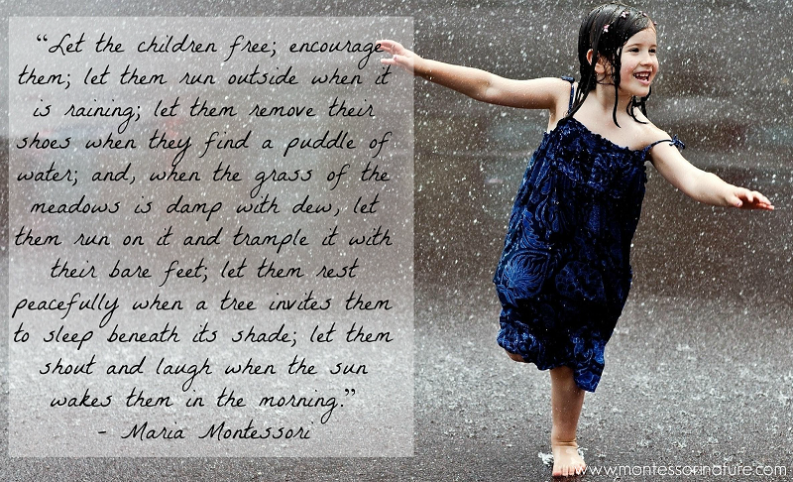
Have a wonderful weekend!

