School Talk

March 22, 2019

Inside this edition:

- APS IPP ProcessProgram News
- Program News
- Three School-Wide Events are Happening!
- Teacher’s Corner
- Reminders
- PTA News
- Upcoming Dates
- Links
- A Montessori Moment

APS IPP PROCESS:
On March 21, a representative from our program attended the APS PreK-12 Instructional Programs Pathway (IPP) meeting. The meeting was hosted by Tara Nattrass, APS Assistant Superintendent for the Department of Teaching and Learning.
IPP is a new visioning project that APS is undertaking to outline what option programs/schools APS wants over the next 10 years or so. The final deliverable, a document report to the School Board due in June, is supposed to help inform APS as new schools are constructed and future boundary changes occur. Information about the IPP process, guiding principles, and timeline can be found at www.apsva.us/prek-12-instructional-programs-pathway-ipp/.
What you need to know: There will be an online community questionnaire, expected April 8-26, at the website above. Also, be on the lookout for a draft IPP framework that will be emerging. A county wide community meeting will be held April 30 at 7 p.m. at Kenmore Middle School.

A full report about the March 21st meeting will be included in the Montessori PTA’s weekly newsletter. Please make sure to look for it.

PROGRAM NEWS
-Attendance Reminder Please call the school before 10AM to report your child’s absence. If you do not call until after 10AM, you will most likely receive a robo-call. You can also send an e-mail to drew.attendance@apsva.us.
-Join the Multicultural Night Committee It’s time to plan our annual Multicultural Night, one of our school’s most favorite events. This year, parents and staff are being invited to take part in the planning. If you would like to join, please attend our first meeting. Tuesday, March 26th at 4PM in the library. The meeting shouldn’t last more than an hour. Any questions? E-mail the lead on this project, Ms. Chandra Perkins at chandra.perkins@apsva.us. Multicultural Night will be celebrated by Model and Montessori together.
-APS Bus Transportation Service Review As the school system has grown and changed, APS transportation challenges have also increased. This Spring, APS is conducting a review of their service, policies and procedures to help create a long-term vision for the bus transportation system and find new solutions to safely deliver students to school on time and ready to learn. They are seeking input from all APS families and community members – bus riders, walkers and those who use other transportation options. Several community workshops are planned from March 25-April 6, and a community questionnaire will go out through School Talk next week to gather input on bus transportation and help inform changes for the 2019-20 school year and beyond. Visit Engage with APS! to learn more and view the event schedule.

THREE SCHOOL-WIDE EVENTS ARE HAPPENING!
-Drew/Montessori Science & Engineering Fair is Wednesday, March 27th! Join both Drew and Montessori students as they showcase their hard work for the annual Science Fair. Their displays will be set up in Drew’s multipurpose room between 4PM and 6 PM for parents, friends, and staff to view. Students will be asked to remain with their projects for part of this time in order to explain their projects and answer questions. The fifth grade projects will be formally judged and awarded ribbons (first place, second place, third place).
-Parent/Staff Talent Show & After School Choir Fundraiser Thursday, March 28th at 6:30PM! Tickets are $3 for adults, $1 for students. Come out and see what talent we have hidden within our community. The show features school staff and parents! Remember, this is a fundraiser for the award winning Afterschool Choir to help offset the cost to Williamsburg, Virginia for the annual chorale festival in May. So come on out and get entertained while supporting a good cause!
-Daddy/Daughter Dance is Friday, March 29th! Tickets are $25 per daddy/daughter combo, $5 for each additional daughter. Unaccompanied daughters are $10 – let Ms. Edwards know your child will be unaccompanied and a surrogate “Dad” will escort her. This is a fundraiser for the Etiquette Club’s June cotillion. If you would like to donate food to this event, please contact Ms. Edwards at Phyllis.edwards@apsva.us. The Daddy/Daughter Dance and Etiquette Club are open to both programs, Model and Montessori.

REMINDERS
-Yearbook Deadline is April 12! Orders are currently being taken for the 2018-2019 Drew Model School Yearbook. The last day to order the yearbook is April 12th so don’t miss your chance! This yearbook includes BOTH Programs, so Montessori students should order this one if they would like a memoire of the year. Order forms went home in this past Thursday’s backpack mail. Send back to school with a check or money order (NO cash please!) made out to “Drew Model School”. Or you may order online at www.ybpay.lifetouch.com today!
PTA NEWS
The Enrichment classes remaining for Session II are as follows:
- Coding: Last class is 3/25.
- Chess and Cupcakes (2nd through 5th grade) is 3/26 and 4/2
- Robotics is 3/27, 4/3, and 4/10 (snow make up day)
- Youth Karate is 3/28, 4/4 and 4/11 (snow make up day)
- Cupcakes (PreK4-1st grade) is 4/5

UPCOMING DATES
- 3/26 OEE Black Parents Alliance, 6:30PM at the Career Center
- 3/26 School Board Budget Work Session #4, 7PM
- 3/27 Bus Transportation Services Review Community Workshop, 7PM
- 3/28 Public Hearing on the Superintendent's Budget, 7PM
- 3/29 End of the Quarter
- 4/1 In-service work day for Teachers

LINKS
- Arlington Montessori Program on APS: https://drew.apsva.us/the-montessori-program/
- Principal Genove on Twitter: https://twitter.com/CSGenove
- Engage with APS https://www.apsva.us/engage/
- Lunch Menus: https://apsva.nutrislice.com/menus-eula-splash
- Arlington Montessori PTA: https://acmpta.com/.

A MONTESSORI MOMENT

Montessori Vocabulary 101

Indirect Preparation: The way nature has of preparing the intelligence. In every action, there is a conscious interest. Through this interest, the mind is being prepared for something in the future. For example, a young child will enjoy the putting together of various triangular shapes, totally unaware that because of this work his mind will later be more accepting of geometry. Also called remote preparation.

Sharing: Montessori Students Doing Great Things!

The Montessori “Walk for Water”
Thanks to all the families and staff for supporting Amman Imman-Water is Life project at school. Many jars of collected coins were turned in and the children seem to be very proud of their contributions.
As a culminating event, some classrooms will participated in a small Walk for Water on March 20th on the field at Drew. An African drummer accompanied them to add culture, rhythm and fun. The idea was to walk in solidarity with the children of the Azawak, children who walk up to 30 miles a day to bring water to their families. Everyone walked across the field 20-30 times, plenty of walking but only a small portion of what the Azawak children walk. The activity ended with a big circle and the singing of “Light a Candle for Peace”. Please enjoy some pictures from the day.
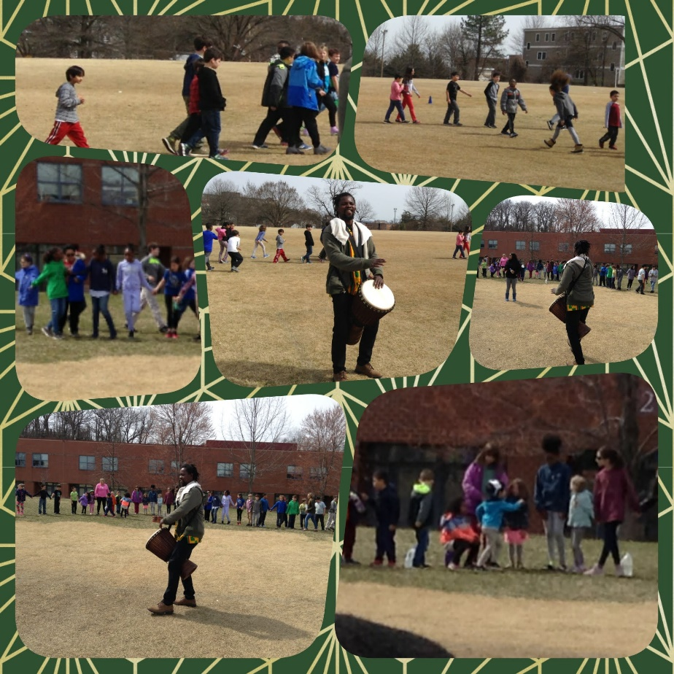

APS District Honors Concert
Congratulations to APSArts Honors musicians Owen Berger, Henry Gee, Henry DeNola, Rhys Harbor, Madeline Dean, Kayla Grant and Charlotte Harold. They represented Drew and Montessori Public School of Arlington beautifully at March 19’s district Honors concert.
