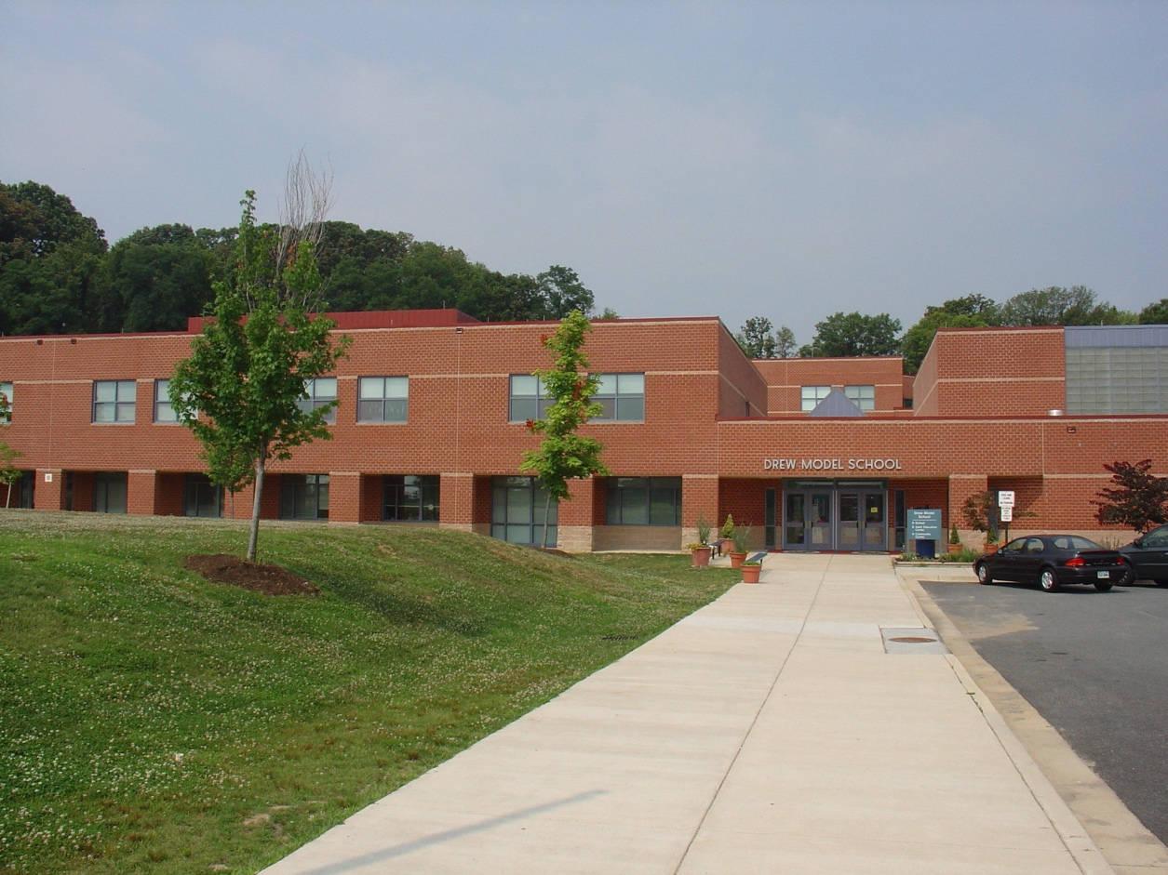  Drew Model Elementary School  “Building Our School Community”  Parent Engagement Meeting  Current and new parents and families are invited to attend a series of Community Engagement meetings focused on building our school community. The meetings will be designed to provide families and parents with information about our school and create opportunities for parents and families to engage with school staff.  TOPIC OF DISCUSSION: School Safety and Security—Captain Wayne Vincent, Corporal Shawn Blow from the Arlington Police Department along with Zachary Pope, Emergency Manager from Arlington Public Schools will be in attendance. | WHEN:  April 24th 7:00pm  WHERE:  Drew Model  Elementary School  3500 23rd Street  Arlington, VA. 22206  NEXT MEETINGS  May 29th  BABYSITTING WILL BE PROVIDED!

