School Talk

March 29, 2019

Inside this edition:

- APS Bus Survey
- Drew’s New Name & History
- Event Synopsis x3 – with Pics!
- Program News
- Reminders
- PTA News
- Upcoming Dates
- Links
- A Montessori Moment

APS BUS TRANSPORTATION SURVEY
Arlington County is doing a school transportation survey to figure out how to plan and operate buses in the future. It is a quick survey, 5-7 minutes, and VERY IMPORTANT for Montessori parents to take, as option schools are some of the most complicated routes in the county. The survey will be open through April 12, but please don’t wait!
https://survey.k12insight.com/survey.aspx?k=SsSRTVsQQTRsPsPsP&lang=0&data
APS also has two more Transportation Workshops planned on April 3 and April 6, a weekend one for working parents to attend. See flyers in English and Spanish below.

DREW’S NEW NAME & HISTORY
On Thursday, March 28 at a little before midnight, the School Board voted in the new name of the program currently known as Drew Model School. Their new name is Dr. Charles R. Drew Elementary School. It will begin being used officially in the fall.
The Montessori program is happy to share this wonderful news as this is the final step to crown the long sought-after neighborhood school in Nauck. We also share this news because many of you, our Montessori families, helped the neighborhood to advocate for a neighborhood school and we know you would be happy to hear the news.
Some history about the Drew Model School:
- 1876 to 1883 the school’s site was home to the Kemper School No. 4, located at Lomax A.M.E. Zion for African-American students. It was only the 2nd school to serve African American students in Arlington District of Alexandria County (as it was known then). The first was Arlington School in Freedman’s Village.
- In 1885 through 1894, the school moved to a building located at 2501 S. Shirlington Road
- 1945 brought the construction of 1-story, 8-room school named the Kemper Annex, which was located on the big field in front of Drew Model School.
- In 1953 the Kemper Annex was renamed Drew Elementary School
- 1961: Twenty-two rooms were added to Drew Elementary and filled with African American students.
- 1971: Desegregation in Arlington had occurred and the school was renamed Drew Model School enrolling students of all races, bussed from across the county, with two programs under one roof: The Montessori Program and the Model Program, which was an individually focused program with open classrooms and taught to multiple intelligences within the same classroom. (The Montessori program piloted with 1 classroom in 1971.)
- 2000: APS replaced the original Drew buildings with the existing building we are now occupying. The educational focus moved from the Model program to a traditional program.
- 2019: The school will open in the fall as a neighborhood school with wider boundaries and a new name.

EVENT SYNOPSIS x3 – WITH PICS!
Last week was a week full of wonderful Montessori/Model events! It was great to see so many families come out to support and participate in our schoolwide activities.

Science & Engineering Fair – Wednesday, March 27.
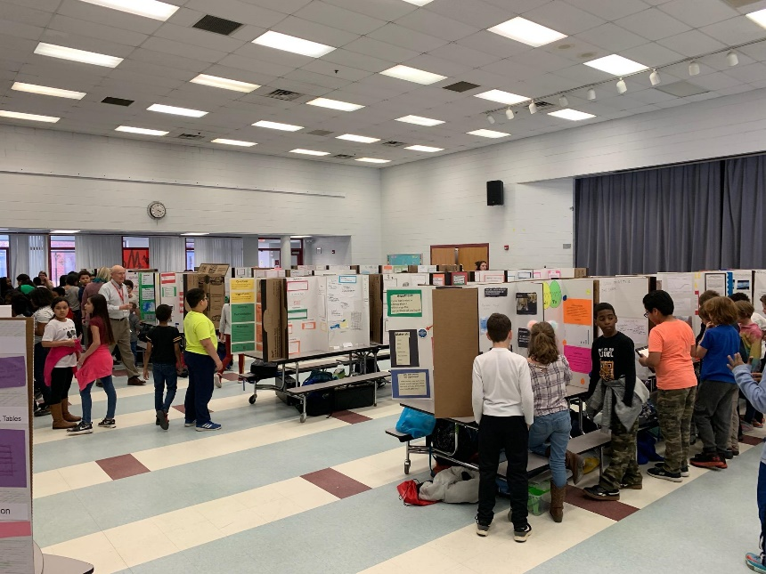

So many incredible projects and experiments were showcased at our annual Science event, chaired by Ms. Eve Mendolia. 4th and 5th graders had mandatory participation requirements, however, there were a lot of children in the lower grades who also submitted projects. Every child received a participation ribbon and the 5th graders were judged on their projects (winners list will be published this Friday).

Parent & Staff Talent Show – Thursday, March 28.
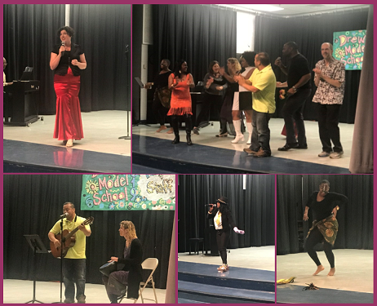

This event was phenomenal! Teachers, parents and neighbors performed in this talent filled show! Singing, dancing, musicians and even juggling! The mic toss to Kool & the Gang’s “Celebration” at the end of the show really brought down the house as everyone in the audience jumped to their feet to dance and sing along. The video of this evening should be available soon.

Daddy Daughter Dance – Friday, March 29.
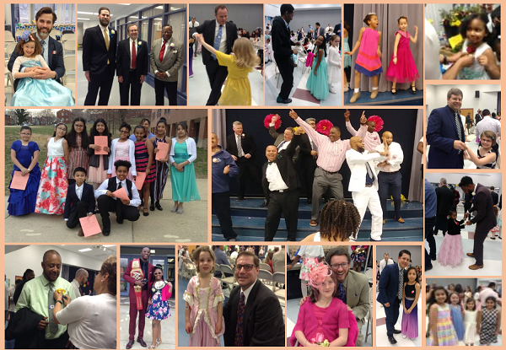

The 2nd annual Daddy Daughter Dance was a huge success! We had 200 fathers & daughters participate (with a few volunteer moms on hand to help things run smoothly). The DJ played a good mix of oldies and new hits, from Earth, Wind & Fire to Maroon 5, and the dance floor stayed busy. We had a few contests and a fashion parade. Every attendee received a free corsage and boutonniere and the Montessori and Model PTAs (plus a few very generous parents) purchased all the food and beverages. This event was sponsored by the Etiquette Club and all proceed will go towards funding their formal cotillion this June.

PROGRAM NEWS
-Mark your calendars for MULTICULTURAL NIGHT! This fun and well-attended event will be Tuesday, April 30 from 6PM to 8PM. For this years’ Multicultural Night, we’ll be asking local, culturally authentic, restaurants to join in on our celebration through donating food. We’re looking for authentic food from each continent. This is something new that we’re trying out this year and we’re really excited about it. We need your help! If you are connected to a restaurant, please consider reaching out to them for food donations. This is being done under the umbrella of Drew Model School, which is a non-profit, so all donations would be tax deductible. Any questions or want to help? E-mail the lead on this project, Ms. Chandra Perkins at chandra.perkins@apsva.us. Multicultural Night will be celebrated by Model and Montessori together.

REMINDERS
-Attendance Reminder Please call the school before 10AM to report your child’s absence. If you do not call until after 10AM, you will most likely receive a robo-call. You can also send an e-mail to drew.attendance@apsva.us.

PTA NEWS
The Enrichment classes remaining for Session II are as follows:
- Coding: Ended
- Chess and Cupcakes (2nd through 5th grade) is 4/2
- Robotics is 4/3, and 4/10 (snow make up day)
- Youth Karate is 4/4 and 4/11 (snow make up day)
- Cupcakes (PreK4-1st grade) is 4/5

UPCOMING DATES
- 4/2 Budget Work Session #5, 7PM at Syphax Education Center, 2nd floor
- 4/2 County Board Budget Hearing, 7PM at 2100 Clarendon Blvd, Room 307
- 4/3 Bus Transportation Community Workshop, W-L at 7PM, Cafeteria
- 4/4 Montessori Information Session, 12:45PM
- 4/6 Bus Transportation Community Workshop, 10AM at Patrick Henry ES, Gym

LINKS
- Arlington Montessori Program on APS: https://drew.apsva.us/the-montessori-program/
- Principal Genove on Twitter: https://twitter.com/CSGenove
- Engage with APS https://www.apsva.us/engage/
- Lunch Menus: https://apsva.nutrislice.com/menus-eula-splash
- Arlington Montessori PTA: https://acmpta.com/.

A MONTESSORI MOMENT

Montessori Vocabulary 101

Mixed Ages: One of the hallmarks of the Montessori method is that children of mixed ages work together in the same class. Age groupings are based on developmental planes. Children from 3-6 years of age are together in the Children's House; 6-9 year olds share the lower elementary and the upper elementary is made up of 9-12 year olds. Because the work is individual, children progress at their own pace; there is cooperation rather than competition between the ages.

Play vs. Work: A Wrong Alternative
by Heike Larson for MariaMontessori.org

Recently, I’ve read several articles in which articulate, well-informed commentators caution parents against emphasizing academics for preschool children, and which advocate “developmentally appropriate play-based preschools” as a better alternative.
Here are some quotes I read this year which illustrate this concern:
A parent recently asked my advice about choosing a preschool for her son. I responded with my belief that the purpose of preschool is socialization, and that a developmental ‘learn through play’ program is best. - Janet Lansbury
There must be a vision for preschool classrooms as engaging, interactive environments, full of open-ended opportunities for play as learning, and focused on early childhood learning guidelines that address the whole child’s learning and development, not just on early academics. - Laurel Bongiorno, writing in the Huffington Post
I’m sure you’ll receive many enthusiastic endorsements of Montessori preschools from satisfied parents, but my son’s play-based preschool was overwhelmingly wonderful and completely perfect for us. I think the Montessori brand name appeals to anxious parents who want to start the academic rat race at age 3. I say save your money, and let your child play while s/he’s young. - Parent response on Berkley Parents Net
These quotes, written by intelligent individuals who obviously understand and care deeply about children’s well-being, are premised on the idea that there is a necessary trade-off between joyful play on the one hand, and rigorous academic learning on the other. On this trade-off view, parents must choose between fun and academics—between a child-led realm from which serious academic learning is mostly absent, or an adult-dominated preschool environment that strongly resembles the failed traditional school model most children enter when they turn six.
The subsequent argument these commentators make against Montessori education is that it represents the “academic” side of the choice between academics vs. fun, and that play-based preschools are superior because they represent the “fun” side.
But is there in fact such a necessary trade-off between academics and childhood play?
Does a parent have to choose between learning and fun?
We don’t think so. In our view, the learning vs. fun trade-off is a false alternative, and in practice the most profoundly joyous childhood environment is precisely the one which best satisfies a child’s cognitive needs.
Children by nature are curious about the world. They are capable of an astounding amount of early learning when given the freedom to explore to their heart’s content, particularly in an environment of carefully prepared engaging, meaningful explorative activities. In such a setting, learning so-called academic skills, such as handwriting or arithmetic, is experienced as a playful, enjoyable activity. The pleasure and deep satisfaction of such concentrated engagement is natural and to-be-expected because it is consistent with the actual needs of the child. Psychologically, the satisfaction derived is exactly the satisfaction that comes from play. As Maria Montessori put it, “play is the child’s work.”
A child’s early years represent an irreplaceable period in his life—a period that biologically serves the purpose of helping him become familiar with the world around him, and capable of purposeful action in pursuit of the things that matter to him. In this time period, certain skills are learned effortlessly that, if delayed to the elementary years, unfortunately become more of struggle for many children (such as building a long attention span, developing refined fine motor control, acquiring neat handwriting, learning to read, and mastering foundational arithmetic skills). The acquisition of these life skills is not an imposition on the child—to the contrary, his whole being is oriented towards acquiring precisely such skills.
But the fact that there’s a developmental benefit to an activity does not mean an activity is not experienced as fun, fulfilling, exciting. Just as the fact that an adult’s need to work does not mean that one’s job must be drudgery, so too a child’s need to grow does not mean growth must be listless. Many adults—indeed, the most fulfilled adults—approach their work as an exciting, satisfying activity, and do not “live for the weekends”. In a Montessori classroom, we don’t assume that activities that have long-term utility must be empty of joy.
Many educators struggle with this apparent chasm between joyfulness, and academic rigor and structure. Progressive educators, following Dewey, usually err on the side of making learning “fun”, even if it means sacrificing a sequenced, comprehensive, rigorous curriculum. Traditional educators, in contrast, excel at defining what academic skills and content a child is to master, but often rely heavily on extrinsic motivators, like grades, class parties or the threat of a trip to the principal’s office, to entice children to do the dreary drilling needed to achieve their goals.
Montessorians need not accept this false alternative. Our vision is not learning vs. enjoyment, but an integrated, joyous learning. Dr. Montessori’s unique method of allowing the child freedom to choose in a carefully prepared environment is the revolution that enables parents to have their cake and eat it, too—to ensure their child will stay curious, joyful and intrinsically motivated to learn, and at the same time master challenging and advanced academic skills and content, from preschool onward.
Let’s spread the word: If this is possible, why would anyone settle for less?
About Heike Larson
Heike Larson is the Vice President of Parent Outreach at LePort Schools, a group of six private Montessori schools in Orange County, CA. She lives in Oakland, CA, with her husband, and her two children, who both attend a Mandarin immersion Montessori program. She writes about education in general and Montessori in particular on the LePort Schools blog.

