School Talk

April 12, 2019

Inside this edition:

- Earth Day Plans
- Talent Show Video
- Spotlight: Outdoor Lab & 4-H Overnight
- Help Make Multicultural Night Great
- Program News
- Reminders
- PTA News
- Upcoming Dates
- Links
- A Montessori Moment

EARTH DAY PLANS
The day we return from Spring break, April 22, is Earth Day. As per our annual tradition, we are asking children to each bring in something to plant. It need not be a large, elaborate plant – a single bud is fine. It also need not come from the store – plants from your home garden are also welcome (just make sure the root is intact). We will be having planting and Earth day activities happening throughout the week. Your child’s teacher will let you know which days they plan on doing activities. This is our last year at Drew Model School and our last Earth Day working together side-by-side with the Model program, so let’s make this a good one by turning our outdoor spaces into a celebration of beauty.

TALENT SHOW VIDEO
Did you miss the awesome Parent/Staff talent show? Well, not to worry! Thanks to Mr. Gildea, our ITC, you can view it here: https://youtu.be/lSNREnghmzY
Some performances have been omitted because they were flagged by YouTube’s copyright police, but most are here. Enjoy!

SPOTLIGHT: OUTDOOR LAB & 4-H OVERNIGHT
The 5th Graders had a great week of outdoor learning and fun! In the earlier part of the week, they visited the Arlington Outdoor Lab. Arlington County has partnered with the Outdoor Lab for many years as it offers a great, hands-on experience for our students at a very minimal cost. Children learn about the flora and the fauna in the area, do experiments and participate in projects. Sadly, with the current budget cuts proposed, this may have been the last year our students have access to such a wonderful experience. For more information about the Outdoor Lab, and what you can do to help save the program, visit https://outdoorlab.org/. Meanwhile, please enjoy some pictures.
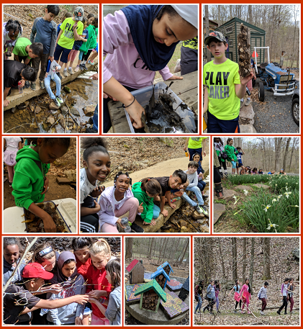
Photo credit: Lisa Hernandez
The end of the week was the annual 5th grade overnight trip to the 4-H Center in Front Royal, Virginia. This field trip has always been named as the highlight of their year – for some, their school career! This year’s trip was bittersweet as it was the last time Montessori & Model would do this trip together. Montessori hopes to be able to continue this trip even when we are established as a standalone program. Please enjoy some pics of the 2-day adventure. A huge thank you to all our adult attendees who volunteered to chaperone.
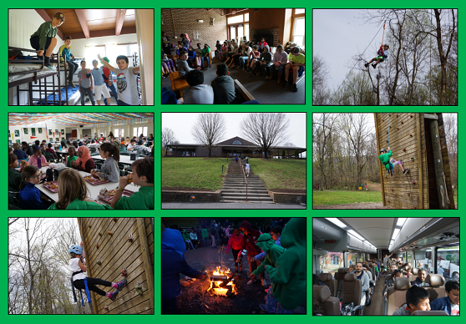
Photo credit: Erika Steinmetz

HELP MAKE MULTICULTURAL NIGHT GREAT
This year’s Multicultural Night is expected to be amazing! But to make it amazing, we need your help. We need parents to lead or assist at interactive learning stations based on the 7 continents. We also need “museum” docents, hosts for the evenings and, of course, help with food, set up and break down. If you are available to help, please sign up here: https://www.signupgenius.com/go/20f0848acac2ca4fe3-multicultural
Want to help in other ways? Such as
- Give a performance from your culture?
- Teach a lesson about your culture?
- Prepare a food to share from your culture?
Then contact the Multicultural Night lead, Ms. Perkins at chandra.perkins@apsva.us and let her know.

PROGRAM NEWS
-Books On, World OFF! Kids inspiring other kids to read – that’s the goal behind a brand new library show at Drew Elementary. Go behind the scenes of the first ever “Books On, World Off” TV Show, directed by students, for students, in this week’s Snapshots. It’s produced in partnership with Gunston video and film students. Check it out! https://www.apsva.us/post/books-on-world-off-behind-the-scenes/
-Service Award A big congratulations to our wonderful school librarian, Dora Sue Black, on being recognized for 30 years of service to APS! She was presented with a service award at last night’s School Board meeting.
-Health Survey The School Health Bureau (SHB) is administered by the County’s Public Health Division, in close coordination with Arlington Public Schools (APS). We strive to provide the best service possible in the school clinics. We’d like to know what we do well and what we can improve upon. Please take a few minutes to tell us about your experiences with your child(ren)’s school clinic during the 2018-2019 school year. Share your feedback online by April 30:
- English Survey: https://www.surveygizmo.com/s3/4927870/2018-2019-School-Health-Parent-Survey
- Spanish Survey: https://www.surveygizmo.com/s3/4927870/esp

REMINDERS
-Last DAY to take the APS Transportation Survey Arlington County is doing a school transportation survey to figure out how to plan and operate buses in the future. It is a quick survey, 5-7 minutes, and VERY IMPORTANT for Montessori parents to take, as option schools are some of the most complicated routes in the county. The survey will be open through midnight tonight, April 12, but please don’t wait! https://survey.k12insight.com/survey.aspx?k=SsSRTVsQQTRsPsPsP&lang=0&data

PTA NEWS
-On Monday, April 8, two of our students were recognized at Northern Virginia District PTA’s Student Awards Program. Ella Engelhardt, 3rd Grade, received the Director’s Award for her literary contribution. Second grader Madison McBeth received first place in region and state for her musical composition. Both students are in Ms. Maheshwari’s class. Congratulations to them both!
-All students started their Original Works artwork last week but we still have a lot of incomplete projects. If your child would like to work on their artwork through spring break, please have them work on any artwork of their or your choice on card stock paper of any color in size 8.5x11, with their name, teacher name and grade on the back. Here are some ideas - https://www.pinterest.com/originalworks/. Students can bring in their artwork to Ms Walchak after spring break.

UPCOMING DATES
- 4/13-4/21 Spring Break
- 4/22 Back to School

LINKS
- Arlington Montessori Program on APS: https://drew.apsva.us/the-montessori-program/
- Principal Genove on Twitter: https://twitter.com/CSGenove
- Engage with APS https://www.apsva.us/engage/
- Lunch Menus: https://apsva.nutrislice.com/menus-eula-splash
- Arlington Montessori PTA: https://acmpta.com/.

A MONTESSORI MOMENT

Montessori Vocabulary 101

Obedience: Obedience is an act of will and develops gradually, showing itself 'unexpectedly at the end of a long process of maturation.' (Montessori, 1967, p. 257) While this inner development is going on, little children may obey occasionally, but be completely unable to obey consistently. As their will develops through the exercise of free choice, children begin to have the self-discipline or self-control necessary for obedience.

Montessori at Home: 15 Spring Activities Your Kids Will Totally Love
by Christina Clemer

Spring is one of the most fun times of the year to explore nature with your child. There are just so many fun changes, from baby animals, different birds migrating through, and all of the beautiful rainbows that come from spring showers.
Here are a few fun Montessori-inspired spring activities to try with your little one this year:
Learn About Weather
In many parts of the country, spring brings rain clouds in addition to warmer weather. Embrace the rainy days as well as the sunshine by exploring the weather.
1. Cloud gazing
Find some pictures of different types of clouds (or use a book) and then enjoy searching for them in the sky. Take it a step further and use cotton balls to create representations of the different kinds of clouds if your child is interested.
2. Rainbows
Spring is a wonderful time to talk about rainbows. Spend time searching for rainbows after rainstorms, and consider getting a prism to let your child explore rainbows even on sunny days. Have fun noticing the order of the colors and provide the correct colors of paint or crayons for your child to create a picture of what he sees.
3. Daily weather report
Use these fun letter board ornaments to allow your child to create her own daily weather report. You could also simply create a booklet with some drawing paper and encourage your little one to draw or paint the weather each day and see how it changes over time.
Observe Animals
From baby animals to butterflies, spring is a wonderful time for children to learn about animals.
4. Bird watching
Spring migration makes it an exceptional time for bird watching. Try talking to your child about the different types of birds he might see this time of year. Have a bird watching adventure in your backyard or nearby park and see how many types you can spot together. Child-sized binoculars can make this even more fun.
5. Filling bird feeders
Filling bird feeders is something even young toddlers enjoy helping with. For older children, try providing several types of seeds and letting them mix or layer them together in the feeder.
6. Study butterflies
Children are understandably captivated by butterflies and spring is a great time to study them. You can simply read a book, or take it a step further and order a live butterfly kit to let your child see firsthand the transformation from caterpillar to a butterfly.
Explore Nature
7. Create a nature table
Define a space such as a small table or even a tray or basket, and allow your child collect interesting things she finds in nature. Include a magnifying glass if you like.
8. Plant a garden
Young toddlers can help water a garden, slightly older children enjoy planting seeds and weeding, and older children can help design a garden and select the plants. Gardening provides an up-close look at how plants grow and is also great for independence and a sense of responsibility.
9. Collect flowers
Encourage your child to find and collect some of the little wildflowers growing everywhere this time of year. It can be especially fun to use a flower press to preserve his finds.
10. Celebrate Earth Day
Plant a tree, clean up a park, or join a community Earth Day event. These all provide a great opportunity to talk to children about their important role in taking care of our planet.
Practical Life
Montessori teachers refer to the practice of real-life activities, like cooking and cleaning, as "practical life." These skills are practiced all year long, but there are some fun and different ways to focus on them in spring.
11. Peel hard-boiled eggs
Spring is a great time to talk about how some animals hatch from eggs. Letting your child peel hard-boiled eggs can be a fun extension of this, and is also a great way to build concentration, as it can take quite a long time and significant effort for a young child to remove all of the little pieces of eggshell.
Show your child how to crack the eggshell and provide a small bowl for her to put the shell in. Bonus: Ground up eggshells are great for the soil in your garden.
12. Hull strawberries
Spring produce provides a great opportunity for little ones to help clean and prepare different fruits and vegetables, including hulling strawberries.
Show your child how to rinse the strawberries and use a strawberry huller. He can also use a chopper to slice them.
13. Scrub outdoor toys
If you're anything like me, your child's water toys got a bit dusty in the long winter months. Get your child involved in cleaning them up for the warmer weather to come. All she'll need is a scrub brush, a bucket of water, and some soap if you wish. She'll have fun making the toys beautiful again, and you can check something off the to-do list—it's a win-win.
14. Scrub rain boots
In many areas, rain boots get a lot of use this time of year. At school, we sometimes put out a boot scrubbing activity for children to clean their muddy boots and this is something you can easily replicate at home. Set up a little cleaning station, perhaps on the back porch, with everything your child needs to clean his boots.
15. Flower arranging
Flower arranging is an activity enjoyed by children in Montessori classrooms all year long, but it is especially fun in the spring when your little one can help pick flowers in the backyard or visit a local market and see all of spring's beautiful flowers displayed.
Set up the activity so that your child can do it herself. In addition to fresh flowers, she'll need scissors to trim the stems, a few little vases to choose from, a small pitcher for water, and a funnel to pour water into each little vase. Your home will look beautiful, and your child will feel so proud knowing that she contributed.
Perhaps the best way to enjoy spring with your child is to simply get outside, splash in the puddles, and soak up the sunshine, but hopefully, these activities will give you a new way to spend time together and enjoy the season.

