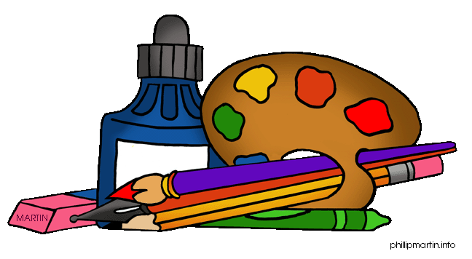**Contest deadline is Friday, December 15, 2017**

**Calling all 3rd, 4th and 5th Grade Model Students!**

**Time to Get Creative!!!**

**Design our Drew’s STEAM Logo Contest!!!**

.

**Would you like to design Drew’s STEAM Logo? No special talent is needed, just creativity and imagination!!!**

**Contest Rules:**

1. **Must include a Drew Dragon as part of the logo artwork.**
2. **Must include the 5 elements of STEAM. (Science, Technology, Engineering, Arts, Math)**
3. **Full scale and must measure 9 in. x 12 in. either landscape or portrait position.**

**Ex:**

1. **Use markers, colored pencil, crayon, paint or paper (collage).**
2. **Must use 2 or more colors and nothing metallic.**

**\*\*Prize is a tee-shirt bearing your logo!!!\*\***

**Judging criteria is based on creativity, clarity of idea, and craftsmanship**

**Winner will be announced Wednesday, December 20th**